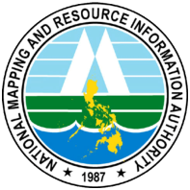 | FEEDBACK FORM
 | NAMRIA-KS-Form15 Rev00

Feedback on your experience at NAMRIA is valuable to us. The details of this experience will help us serve you better the next time you visit us. Please put a check mark on the nature and subject of the feedback you are providing us.

What is the nature of your feedback?

 | Commendation |  | Comment |  | Counsel (Suggestion) |  | Complaint

What is the subject of your feedback?

 | Products and Services |  | Procedures |  | People |  | Premises and Facilities

Feedback Details:

Thank you. Rest assured that the feedback you shared with us will be treated confidentially. We shall advise you of the action taken on the matter.

Contact Details
Name:
Sex:
Address:
Phone Number:
Email Address:
Date Accomplished:
Signature:
Receiving Personnel:
Printed Name and Signature
Date Received:

For more inquiries, you may:

Visit us at www.namria.gov.ph
Call us at +632 8875466 or +632 8104831 local 444
Email us at oss@namria.gov.ph

